+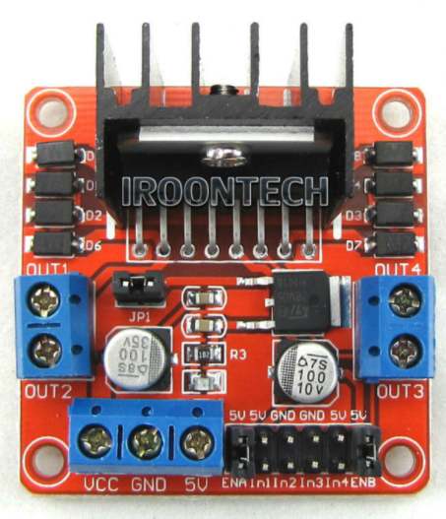

WIRING DIAGRAM – L298 TP ROBOT CAR

RIGHT MOTOR

LEFT MOTOR

-ve 6 VOLT BATTERY

+ve 6 VOLT BATTERY

GPIO 19

GPIO 21

GPIO 20

GPIO 26

RPI – GND PIN

LN298

LEFT MOTOR

IN1 – Purple 19

IN2 – White 26

RIGHT MOTOR

IN3 – Brown 20

IN4 – Black 21

#Python Code for L298N Robot

#https://www.youtube.com/watch?v=XvOONPSoglY&t=788s

from gpiozero import Robot

import curses

from time import sleep

robot = Robot(left=(19,26), right=(20, 21))

screen = curses.initscr()

curses.noecho()

curses.cbreak()

screen.keypad(True)

try:

while True:

char = screen.getch()

print(char)

if char == ord('q'):

break

if char == ord('s'):

robot.stop()

elif char == curses.KEY_UP:

robot.forward(.9)

elif char == curses.KEY_LEFT:

robot.left(.8)

sleep(.5)

robot.forward(.9)

elif char == curses.KEY_RIGHT:

robot.right(.8)

sleep(.5)

robot.forward(.9)

elif char == curses.KEY_DOWN:

robot.backward(.8)

finally:

curses.nocbreak(); screen.keypad(0); curses.echo()

curses.endwin()

#save it as robby.py

#Go To Raspberry Pi Terminal >_

#type

pi@raspberrypi:~$ python robby.py

or

pi@raspberrypi:~$ python3 robby.py